1. Create New policy

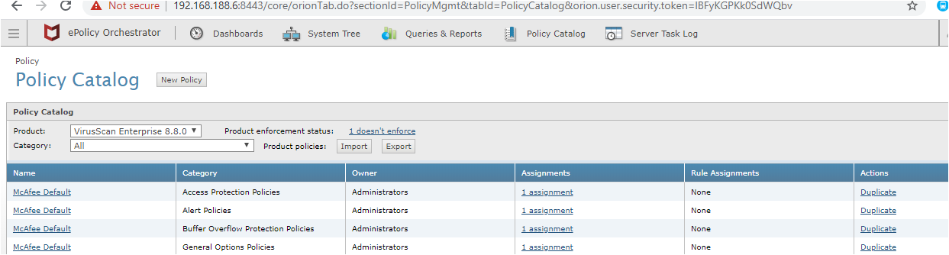

**1**

**3**

**2**

Give name to copied policy

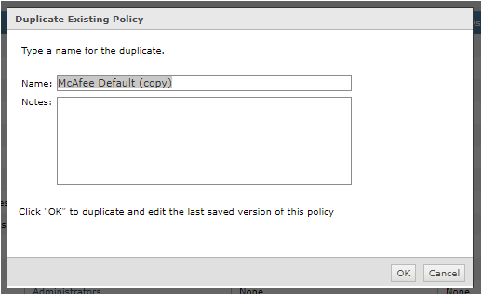

**4**

1. Create New Group.

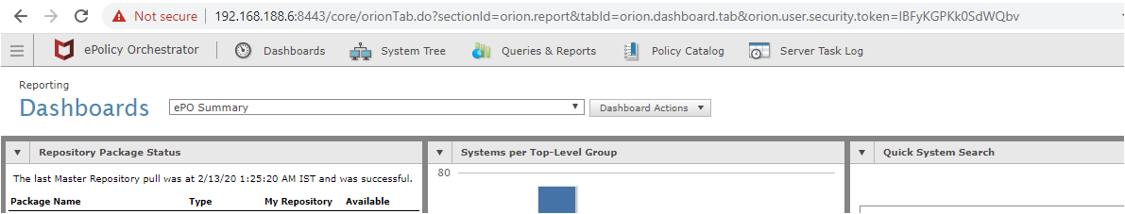

**5**

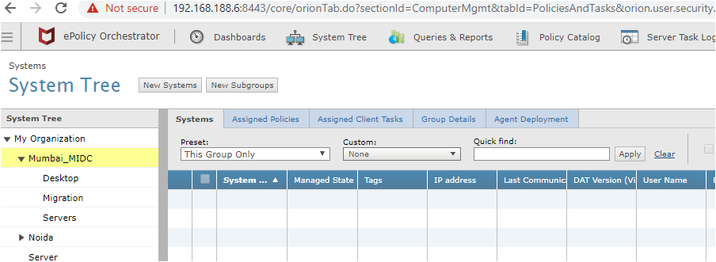

**7**

**6**

1. Assign group to policy



**9**

**8**

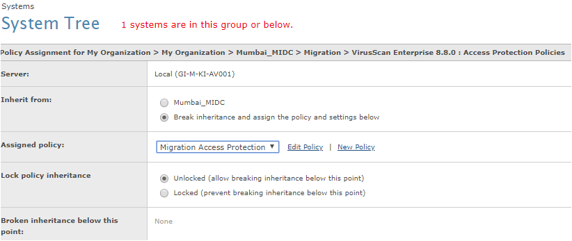

**10**

1. **Add Computer to Group**

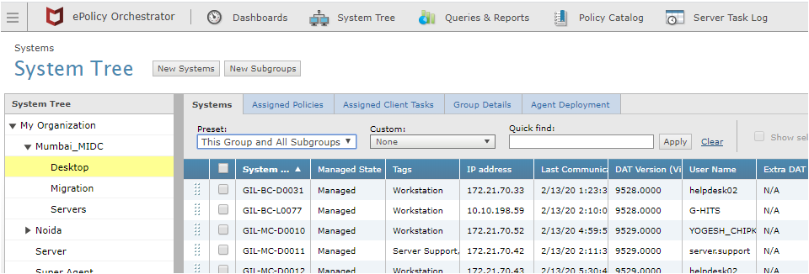

**13**

**12**

**11**

**11**

**11**

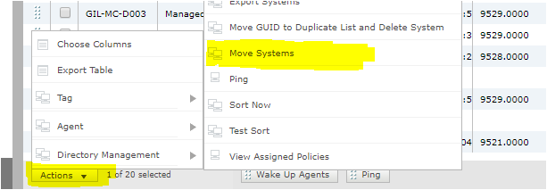

**15**

**14**

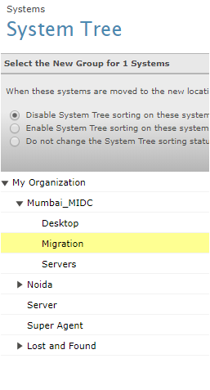

**16**

Select computer to apply policy > goto “Action” and Wakeup Agent.

With above process we can create policy catalog to disable

1. Access Protection (duplicate copy of Access Protection Policies)
2. On Access Scanner (duplicate copy of On-Access General Policies)

